Epsom & Ewell F.C.
19
v
Bedfont Sports
Saturday, 13th February 2016 – 3.00 p.m.
Good afternoon! We welcome the players, supporters and officials of Bedfont Sports Football Club for a League match, together with today’s match officials and our own regular supporters.

This is the return fixture in the sequence, having of course drawn 2-2 over there back in November. We are still counting the cost of that match and although no blame attaches to our opponents, I am unable to comment further on the game, except to say that most people would feel that our club were extremely harshly dealt with on the night and subsequently.

Under the circumstances it is easy to forget that we were nearly defeated, requiring a fortunate late equaliser from Rob Hendry to retrieve a point. However, I felt we were the better side on the night and our players will undoubtedly be keen to redress the matter today.

We were last in action here against Redhill, when we claimed our first points of the new year by a comfortable looking margin of three goals to nil. However, Redhill put up a spirited performance and although it is probably too late for them to climb out of the bottom two, I am sure that, if they are actually relegated as looks likely, we’ll see them bounce straight back.

We then suffered another postponement at Farnham, before travelling to Camberley on Tuesday for a match brought forward from next Saturday as they have a slightly more interesting looking F.A. Vase Quarter-Final at Hereford to deal with! Anyway, on the night I thought we were the better side and after responding to their penalty with one of our own we came away with a 1-1 draw. We wish them well in their travels to the Welsh border.

Following today’s encounter we travel to AFC Hayes on Tuesday and then have seven days off before hosting Hartley Wintney on Tuesday and then Horley Town on the following Saturday. This is an extremely testing section of our season, although nobody said it had to be easy!

And we have had some playing changes as a result. Firstly, Alex McGregor has left us and joined Hanworth Villa, while Jakub Kurdziel and Tayo Ajayi have also left us. In their places come the returning Sam Robinson from Molesey, Elliott Thompson from Dorking Wanderers and Bentley Graham from Chipstead. From what I have seen so far, this makes us a stronger team.

If you are a regular supporter, can I please ask you, if you have not already done so, whether you would be able to sponsor a player or a match? A player costs £40, while sponsoring a match and match ball together costs slightly more at £55 but does come with three free entries, programmes advertising in the programme and hospitality. We also offer the opportunity for a youngster to be a mascot for a day, so if you have one who likes football then what better opportunity could you get than to get them walking out with the team and having a kick around on the pitch with them!

Enjoy the game, which incidentally is our 400th Combined Counties League fixture!

Rich

Keep up with us on Facebook www.facebook.com/epsomandewellfc and on Twitter @EEFCOfficial

Cover Photos by Gemma Jarman

- Kyle Hough appears to take on half the Redhill team in scoring our opener on Tuesday!

- Alex McKay heads the winner when we last beat Bedfont Sports here on 7th September 2013

Cherry Red Records Combined Counties League
Premier Division Table 2015/16
inc Tuesday 9th February | P | W | D | L | F | A | Pts | GD | H | A
Hartley Wintney | 24 | 20 | 2 | 2 | 74 | 23 | 62 | +51 | 23/2 | 3-3
Ashford Town (Mx) | 27 | 20 | 2 | 5 | 75 | 36 | 62 | +39 | 30/4 | 3-2
Camberley Town | 24 | 17 | 4 | 3 | 49 | 20 | 55 | +29 | 16/4 | 1-1
Epsom & Ewell | 25 | 15 | 8 | 2 | 59 | 23 | 53 | +36 | X | X
Hanworth Villa | 26 | 15 | 3 | 8 | 51 | 35 | 48 | +16 | 5-0 | 23/4
Colliers Wood United | 31 | 14 | 4 | 13 | 62 | 52 | 46 | +10 | 3-1 | 3-0
Horley Town | 25 | 13 | 5 | 7 | 59 | 35 | 44 | +24 | 27/2 | 2-2
Raynes Park Vale | 26 | 12 | 2 | 12 | 52 | 51 | 38 | +1 | 3-1 | 28/3
Spelthorne Sports | 25 | 10 | 6 | 9 | 47 | 47 | 36 | 0 | 1/3 | 6-2
Knaphill | 22 | 11 | 2 | 9 | 46 | 35 | 35 | +11 | 12/3 | 1-1
Windsor | 27 | 9 | 8 | 10 | 47 | 52 | 35 | -5 | 2-2 | 1-2
Sutton Common Rovers | 26 | 10 | 3 | 13 | 48 | 51 | 33 | -3 | 3-1 | 2-1
Farnham Town | 23 | 9 | 4 | 10 | 42 | 36 | 31 | +6 | 1-0 | 22/3
Bedfont Sports | 25 | 7 | 8 | 10 | 35 | 36 | 29 | -1 | 13/2 | 2-2
Chertsey Town | 27 | 8 | 5 | 14 | 36 | 47 | 29 | -11 | 0-1 | 5/3
Guildford City | 26 | 8 | 5 | 12 | 47 | 60 | 29 | -13 | 4-0 | 2/4
AFC Hayes | 27 | 8 | 5 | 14 | 37 | 53 | 29 | -16 | 1-1 | 16/2
Badshot Lea | 24 | 8 | 1 | 15 | 30 | 64 | 25 | -34 | 9/4 | 1-0
Westfield | 20 | 6 | 6 | 8 | 25 | 34 | 24 | -9 | 26/3 | 0-0
Chessington & Hook | 26 | 7 | 2 | 17 | 42 | 67 | 23 | -25 | 1-0 | 19/3
Redhill | 21 | 3 | 3 | 15 | 25 | 53 | 12 | -28 | 3-0 | 1-0
Cove | 23 | 1 | 0 | 22 | 12 | 90 | 3 | -78 | 15/3 | 7-0

Lucky Day? – 13th February
Played 13 - W 6 D 2 L 5 - F 22 A 20 - PPG 1.54 - Above Average
Our Club record against today’s visitors
Played 8 - W 4 D 2 L 2 - F 12 A 10 - PPG 1.75 - Good
Largest wins and losses against today’s visitors
9th October 2012 - (A) W 3-0 - League Cup - 18th August 2012 - (H) L 0-4 - League
Their Last visit
Saturday 11th October 2014 - L 0-1 - Combined Counties League

Club Captain - Sam Currie
Good Afternoon and welcome to High Road for today’s encounter against Bedfont Sports.

We go into the game on the back of two solid performances knowing that at this stage of the season three points today at home is a priority. However, we know these will not come easily against a well organised side.

Having been privileged to sit on the bench for the last couple of weeks, you can see things are starting to click and the squad is as strong as it has been all season. With the additional signings of Bentley Graham and Elliott Thompson and the imminent return of Dazza, JT, Ali D & Downsey we are set fair to have a good attempt at staying near the summit of what is a tough league.

Our latest result against a tough Camberley side, in which we claimed a well-earned draw – I would strongly argue we deserved more than this – limiting the hosts to a couple of half chances, whilst having some fantastic chances to take more than a point away from Krooner Park, which is always a difficult place to go.

We know that if we look after ourselves and pick up as many points as possible in the second part of the season – with the quality we have – we should be there or thereabouts, but we know this isn’t easy and the old cliché of one game at a time is no more important than here today.

We are hoping for a decent game today, and wish all Players, Coaching Staff and Supporters from Bedfont Sports a safe journey home after the game.

Thank you for your continued support. Up The Salts!

Sam

Club Manager - Glyn Mandeville
Good afternoon everyone and welcome to today’s game against Bedfont Sports.

we come into today's game having played very well in the last two games and feel we should have got two wins out of them but for a very tough Camberley side.

Again, today's game should be a very tough encounter after the last time we met. The lads have worked very hard, especially with games getting called off due to weather.

I hope you enjoy this afternoon’s game and have a safe trip home.

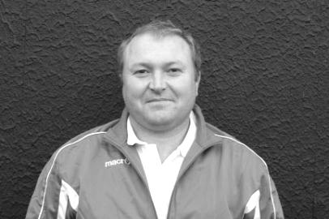
Cheers for all your support.

Manders

Latest Results and Fixtures
Combined Counties League Cup – Tuesday 12th January
Camberley Town | 5-1 | Spelthorne Sports
Epsom & Ewell | 0-3 | Ashford Town (Mx)
Surrey Senior Cup – Tuesday 12th January
Whyteleafe | 6-0 | Farnham Town
Combined Counties League – Tuesday 12th January
Horley Town | 0-1 | Hartley Wintney
F.A. Vase Fourth Round – Saturday 16th January
Hartley Wintney | 3-1 | Bradford Town
Kidlington | 3-2 | Knaphill
Combined Counties League – Saturday 16th January
Badshot Lea | 2-1 | Windsor
Chertsey Town | 3-0 | Chessington & Hook United
Colliers Wood United | 3-1 | Westfield
Cove | 1-6 | Farnham Town
Epsom & Ewell | p-p | Spelthorne Sports
Guildford City | 1-1 | Horley Town
Hanworth Villa | 5-0 | AFC Hayes
F.A. Vase Fourth Round – Saturday 23rd January
Bowers & Pitsea | 3-0 | Sutton Common Rovers
Combined Counties League – Saturday 23rd January
Ashford Town (Mx) | 7-1 | Chessington & Hook United
Bedfont Sports | 1-0 | Westfield
Colliers Wood United | 1-4 | Camberley Town
Farnham Town | 1-0 | Spelthorne Sports
Guildford City | 0-0 | Hanworth Villa
Hartley Wintney | 3-0 | AFC Hayes
Horley Town | 3-0 | Cove
Knaphill | 4-0 | Chertsey Town
Windsor | 2-1 | Epsom & Ewell
Combined Counties League – Tuesday 26th January
AFC Hayes | p-p | Epsom & Ewell
F.A. Vase – Fifth Round – Saturday 30th January
Camberley Town | 5-0 | Newton Aycliffe
Combined Counties League – Saturday 30th January
Ashford Town (Mx) | 1-1 | Colliers Wood United
Chertsey Town | 5-1 | Redhill
Cove | 0-1 | Raynes Park Vale
Latest Results and Fixtures
Combined Counties League – Saturday 30th January
Sutton Common Rovers | 3-2 | Bedfont Sports
Combined Counties League Cup – Tuesday 2nd February
Hartley Wintney | 0-1 | Chessington & Hook United
Surrey Senior Cup – Tuesday 2nd February
Badshot Lea | 1-5 | Merstham
Knaphill | 3-0 | Chipstead
Combined Counties League – Tuesday 2nd February
Cove | 0-1 | Camberley Town
Epsom & Ewell | 3-0 | Redhill
Horley Town | 4-1 | Westfield
Raynes Park Vale | 3-1 | Windsor
Combined Counties League – Wednesday 3rd February
Colliers Wood United | 1-1 | Bedfont Sports
F.A. Vase – Fifth Round – Saturday 6th February
Hartley Wintney | 1-4 | Hereford FC
Combined Counties League – Saturday 6th February
AFC Hayes | 1-1 | Spelthorne Sports
Badshot Lea | 0-4 | Ashford Town (Mx)
Chertsey Town | 4-2 | Windsor
Colliers Wood United | 3-2 | Cove
Guildford City | 0-2 | Bedfont Sports
Hanworth Villa | 2-1 | Chessington & Hook United
Horley Town | 1-3 | Camberley Town
Raynes Park Vale | 2-1 | Sutton Common Rovers
Redhill | 1-2 | Knaphill
Surrey Senior Cup – Tuesday 9th February
Westfield | 1-4 | Woking
Match played at Woking F.C.
Combined Counties League – Tuesday 9th February
Camberley Town | 1-1 | Epsom & Ewell
Cove | 0-3 | Hanworth Villa
Hartley Wintney | 4-2 | Chertsey Town
Knaphill | 4-2 | Ashford Town (Mx)
Combined Counties League – Saturday 13th February
Ashford Town (Mx) | V | Westfield
Badshot Lea | V | Colliers Wood United
Cove | V | Chertsey Town
Epsom & Ewell | V | Bedfont Sports
Latest Results and Fixtures
Combined Counties League – Saturday 13th February
Farnham Town | V | Sutton Common Rovers
Guildford City | V | AFC Hayes
Hanworth Villa | V | Horley Town
Hartley Wintney | V | Camberley Town
Knaphill | V | Chessington & Hook United
Spelthorne Sports | V | Raynes Park Vale
Windsor | V | Redhill
Combined Counties League Cup – Tuesday 16th February
Cobham | V | Frimley Green
Knaphill | V | Chertsey Town
Raynes Park Vale | V | Westfield
Redhill | V | Farnham Town
Combined Counties League – Tuesday 16th February
AFC Hayes | V | Epsom & Ewell
Camberley Town | V | Spelthorne Sports
Chessington & Hook United | V | Sutton Common Rovers
Cove | V | Badshot Lea
Hanworth Villa | V | Guildford City
Hartley Wintney | V | Bedfont Sports
F.A. Vase – Quarter - Final – Saturday 20th February
Hereford FC | V | Camberley Town
Combined Counties League – Saturday 20th February
AFC Hayes | V | Windsor
Ashford Town (Mx) | V | Cove
Chertsey Town | V | Badshot Lea
Chessington & Hook United | V | Westfield
Colliers Wood United | V | Guildford City
Horley Town | V | Spelthorne Sports
Knaphill | V | Farnham Town
Raynes Park Vale | V | Bedfont Sports
Redhill | V | Hanworth Villa
Sutton Common Rovers | V | Hartley Wintney
Combined Counties League – Tuesday 23rd February
Badshot Lea | V | Westfield
Cove | V | Spelthorne Sports
Epsom & Ewell | V | Hartley Wintney
Farnham Town | V | Camberley Town
Redhill | V | Chessington & Hook United

Bedfont Sports F.C. – History
Bedfont Sports Club was founded in 2002, when with considerable help from the local Council a lease was taken out on the near derelict Hatton Road Recreation Ground.

The only building on the site was refurbished to allow use as a bar and clubhouse on the ground floor and changing rooms on the upper one. Most of this work was carried out or supervised by the Chairman Dave Reader. Much work was also done to the playing area to provide playable pitches for Bedfont Sports on Saturdays and Bedfont Sunday, one of the oldest Sunday teams in Middlesex, on Sundays. To give the Club a junior section Bedfont Eagles, formed in 1978, joined the two adult Clubs a short time later.

Bedfont Sports started in the Hounslow and District League for two seasons and then joined the Middlesex County Football League, this being a feeder League to Step 5. More work was needed to enable the team to play in the Premier Division of the MCFL to which they gained promotion in 2004/05. After many ups and downs promotion was finally achieved to the Combined Counties Reserve Division in season 2008/09.

During this time applications were made to the F A and the Football Foundation for funds to enable Flood Lights and a new Dressing Room block to be built together with a 3G five a side pitch. This finally materialised in 2010/11 to give the state of the art complex now available at Bedfont Sports.

In the Combined Counties League Bedfont gained promotion to the Premier Division in season 2011/12 and have spent the past two seasons consolidating that position.

Permanent fencing now surrounds the ground and a 150 seater stand has been installed.

Bedfont Sports is a true Community Club catering for 16 Junior Teams. a girls team, a youth section and two adult teams on a Saturday and Sunday.

The Youth Section is particularly vibrant playing in the Ryman Youth League and having won the Combined Counties under 18 Cup twice in the last four seasons. Players from the Youth section make the step up to adult football, at least five from that section being regulars in the first team at present.

A successful kick boxing club use the facilities together with a boxing club, a rugby team and three darts teams.

The bar area has been recently refurbished as a Sports bar with televisions on all walls.
A Club such as Bedfont Sports could not exist without sponsors so a big thank you to them and to the volunteers who give their time on match days and to the marking and upkeep of the ground and facilities.

First Eleven Appearances - (max 30 – including Camberley Town – 09/02/16)
Name | Debut | 2015/16 |  |  |  | Career Totals
 |  | App | Sub | Total | Goals | App | Sub | Total | Goals
AJAYI Tayo* | 22/08/2015 | 0 | 2 | 2 | 0 | 0 | 2 | 2 | 0
COOPER-SMITH Daryl | 03/01/2015 | 15 | 4 | 19 | 8 | 24 | 7 | 31 | 14
CURRIE Sam | 04/08/2012 | 16 | 2 | 18 | 1 | 124 | 11 | 135 | 3
DAVISON Conor* | 22/08/2015 | 1 | 2 | 3 | 0 | 1 | 2 | 3 | 0
DEAN Dan | 02/08/2014 | 21 | 2 | 23 | 0 | 57 | 3 | 60 | 0
DOWNS Carl | 17/09/2011 | 5 | 1 | 6 | 0 | 99 | 14 | 113 | 2
EACOTT Michael | 02/08/2014 | 27 | 0 | 27 | 0 | 73 | 0 | 73 | 0
FARRELL Matt | 02/08/2014 | 29 | 0 | 29 | 5 | 70 | 3 | 73 | 12
FERDINANDO Matt | 20/09/2014 | 19 | 1 | 20 | 6 | 46 | 5 | 51 | 12
GRAHAM Bentley | 09/02/2016 | 1 | 0 | 1 | 0 | 1 | 0 | 1 | 0
GRIFFIN Reisse | 08/08/2015 | 13 | 5 | 18 | 1 | 13 | 5 | 18 | 1
HASTINGS Craig | 08/08/2015 | 23 | 3 | 26 | 0 | 23 | 3 | 26 | 0
HATFIELD Jamie | 11/11/2006 | 1 | 0 | 1 | 0 | 249 | 13 | 262 | 6
HENDRY Rob | 08/08/2015 | 25 | 4 | 29 | 10 | 25 | 4 | 29 | 10
HOUGH Kyle | 14/08/2007 | 23 | 2 | 25 | 18 | 319 | 17 | 336 | 189
JONES Adrian | 06/08/2011 | 2 | 1 | 3 | 0 | 22 | 1 | 23 | 0
KURDZIEL Jakub* | 29/08/2015 | 1 | 0 | 1 | 0 | 1 | 0 | 1 | 0
MARVELL Dale* | 15/01/2000 | 8 | 4 | 12 | 1 | 269 | 49 | 318 | 86
McGREGOR Alex* | 08/08/2009 | 7 | 3 | 10 | 2 | 179 | 59 | 238 | 29
MCKAY Alex | 20/12/2008 | 21 | 1 | 22 | 0 | 106 | 27 | 133 | 8
NEALE Thomas | 13/10/2015 | 9 | 9 | 18 | 5 | 9 | 9 | 18 | 5
NEILL David* | 03/10/2015 | 1 | 1 | 2 | 0 | 1 | 1 | 2 | 0
NORTH Rhys | 16/08/2015 | 11 | 7 | 18 | 0 | 11 | 7 | 18 | 0
OLIVER Beckett | 29/08/2015 | 5 | 11 | 16 | 0 | 5 | 11 | 16 | 0
PANAYIOTOU Savvas | 03/01/2015 | 5 | 2 | 7 | 1 | 21 | 5 | 26 | 4
ROBINSON Sam | 22/10/2011 | 0 | 1 | 1 | 0 | 54 | 5 | 59 | 13
ROWE Steve | 27/08/2011 | 0 | 1 | 1 | 0 | 24 | 3 | 27 | 0
SMITH Matt | 08/08/2009 | 0 | 0 | 0 | 0 | 91 | 43 | 134 | 10
TANTON Matt | 02/08/2014 | 24 | 0 | 24 | 0 | 42 | 4 | 46 | 1
TAYLOR James | 26/08/2013 | 17 | 2 | 19 | 2 | 73 | 10 | 83 | 5
THOMPSON Elliott | 09/02/2016 | 0 | 1 | 1 | 0 | 0 | 1 | 1 | 0
Own Goal |  |  |  |  |  |  |  |  | 1
* Player has left the club

EL Records Premier Challenge Cup
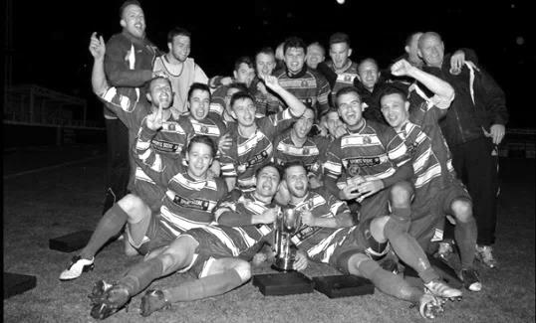
Second Round
Dorking Wanderers | 2-1 | South Park Reserves
Westfield | 1-0 | CB Hounslow United
Bedfont & Feltham | 1-5 | Colliers Wood United
Dorking | 0-3 | Knaphill
Badshot Lea | 2-4 | Spelthorne Sports
Hanworth Villa | 1-2+ | Chertsey Town
Ashford Town (Mx) | 2-1 | Epsom Athletic
Hartley Wintney | 4-2 | Horley Town
Banstead Athletic | 1-1+ | Epsom & Ewell
Epsom & Ewell won 7-6 on penalties
Sheerwater | 3-3+ | Frimley Green
Frimley Green won 8-7 on penalties
Farnham Town | 3-2 | Abbey Rangers
Camberley Town | 4-2 | Eversley & California
AFC Hayes | 0-1 | Banstead Athletic
Redhill | 3-0 | Sutton Common Rovers
Worcester Park | 1-5 | Chessington & Hook United
Cove | 1-6 | Cobham
Third Round
Camberley Town | 5-1 | Spelthorne Sports
Cobham | 16/2 | Frimley Green
Redhill | 16/2 | Farnham Town
Raynes Park Vale | 16/2 | Westfield
Epsom & Ewell | 0-3 | Ashford Town (Mx)
Colliers Wood United | 6-0 | Dorking Wanderers Reserves
Knaphill | 16/2 | Chertsey Town
Hartley Wintney | 0-1 | Chessington & Hook United
Quarter - Finals
Cobham / Frimley Green | 1/3 | Raynes Park Vale / Westfield
Knaphill / Chertsey Town | 1/3 | Redhill / Farnham Town
Camberley Town | 1/3 | Colliers Wood United
Chessington & Hook United | 1/3 | Ashford Town (Mx)

From behind the goal
Epsom & Ewell 0-3 Ashford Town (Mx)
Combined Counties League Cup – Third Round – Tuesday 12th January 2016

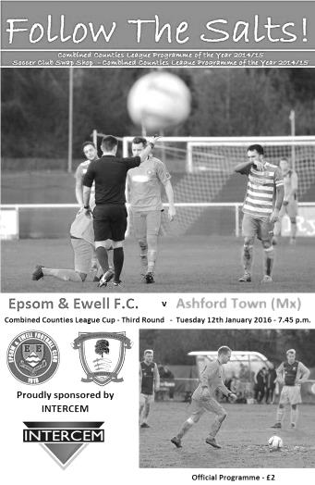
Salts depart League Cup with a whimper

After a two week break we came up against a very good Ashford Town side and were in the end comfortably defeated in this League Cup Third Round tie.

There were very few positives to take from this match in all honesty as we were caught cold by an early goal at the start of both halves, then conceded once more as we pushed to get back into the game. The visitors were well deserving of their victory and held the edge in every department, most notably up front where Dan Fleming scored all three of their goals, all of which were scored from inside the six yard box.

Upon looking at the team sheet it was disappointing to note the continued absence of Matt Ferdinando, Sam Currie and James Taylor, as their injuries have proven much more difficult to shake off than was at first thought. Taylor was on the bench as was Carl Downs, but neither came on. Throw in the suspended Matt Tanton and this left us without our first choice full backs for this important match. In place of Currie and Tanton were the versatile Alex McKay at right back, while our recently signed former Captain Jamie Hatfield would fill the left back slot, although by his own admission, he hadn't played for a while and it will take him a few weeks to get back to match fitness, lasting just under the hour before having to come off.

Under the circumstances it might have been better to face a team lower down the table but the League Cup had paired us with the league leaders and we were just going to have to make the best of it. However, we just didn't get going, and a break down our right flank ended up with a heavy touch from Matt Farrell who needlessly conceded a corner. From the short corner, one of many they exploited throughout the match, a low shot was sent in and it appeared that Michael Eacott was unsighted at first. Bearing this in mind, he did really well to get down and block the initial strike, but we didn't follow the ball in and there was Fleming, stood next to a visiting team mate who had the simple job of tapping the loose ball into the net while we looked forlornly at the Assistant Referee for an offside that wasn't there. We had only been playing for 100 seconds.

An early goal is always a concern, but you could argue that we were going to have to score to win the game anyway, so nothing had really changed, and we were nearly on level terms within a minute after a corner of our own was headed at goal by Craig Hastings, but Joe Green headed the ball off the line and from the half clearance Reisse Griffin sent a stinging shot a couple of feet over the bar from fully thirty yards.

Both sides looked dangerous going forward, with Savvas 'Agi' Panayiotou causing trouble with some early attacking runs, and the midfield battles were both combative and

competitive, but very little in the way of real interest really happened at either end with exception of a booking for either side. We then missed a chance to equalise in the 38th minute when from a free kick on the edge of the box was drilled in low by Rob Hendry and Griffin got a toe to it but poked the ball just wide of the near post with visiting keeper Tobin heading towards the far post.

As the half neared its end Griffin hit another powerful volley just over the bar from the angle of the penalty area after outmuscling a defender and Tom Neale saw his shot deflected for a corner after Farrell had originally broken through and challenged for a loose ball with Tobin. We did have a scare of our own in injury time when McKay sliced a ball across field and Fleming was onto it, just getting a toe to the ball ahead of Eacott, but his touch was heavy and the ball ran out for a goal kick before he could reach it.

If we thought we had got away with it after that narrow escape, those thoughts were crudely shattered within three minutes of the second half when we lost the ball in midfield after having a shout for a handball turned down and a ball over the top of our defence to their right winger enabled him to get to the line and pull the ball back across goal where Fleming was totally unmarked again and knocked the ball into the net in similar fashion to his first goal.

A similar move just moments later required a good save from Eacott and soon after Hastings was required to head clear a goalbound effort. We were struggling at this point but weathered the storm and in the 57th minute nearly got back into it when a Farrell cross from the left wing was caught and then dropped by Tobin under a bit of pressure from Neale. The ball fell to the ground and rolled in and just for a moment it looked like the goal had been given as there was no signal from either official before the referee just decided to award a free kick without blowing his whistle at any point. It was debateable whether there really was a foul by Neale, but those sort of incidents are usually ruled in favour of the keeper and so it went.

We were starting to exert a bit of pressure and when Neale and then Hough were fouled in the same move, the latter challenge earned a yellow card for the visiting skipper Canderton, but the move had been broken up which was the original intention and we were unable to make the set piece count. Neale picked up his own yellow card just after this before one of our substitutes Alex McGregor sent a strike towards the far corner but it was headed away by a defender and moments later the game was all over as another right wing cross was headed in by the unmarked Fleming at close range in the 77th minute with Eacott having no chance.

And they could have had two more as the visitors broke through again, but the first time the attacker was off balance the shot was sliced well wide and on the second, Eacott stood up well and made the save. Ultimately on a very cold night we produced a very cold performance and whilst it could be argued that we had been out of action for a week or two, we need to ensure that we improve for Saturday when Spelthorne Sports visit us for a League match or we will find our title chances slipping away as quickly as our cup chances did this evening.

Team: Michael Eacott, Alex McKay, Jamie Hatfield, Craig Hastings, Dan Dean, Savvas 'Agi' Panayiotou, Rob Hendry, Matt Farrell (c), Kyle Hough, Tom Neale, Reisse Griffin

Subs: Rhys North for Hatfield (53), Alex McGregor for Hendry (67) Beckett Oliver for Griffin (82)

From behind the goal
Windsor 2-1 Epsom & Ewell
Combined Counties League – Premier Division – Saturday 23rd January 2016

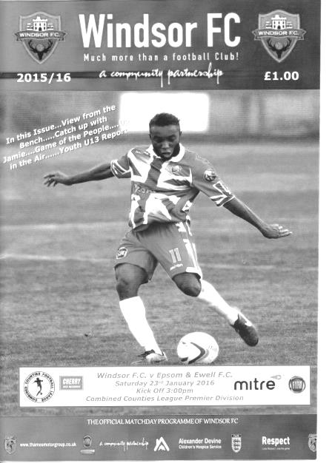
Salts let lead slip and are unable to recover

On the opening day of the season Windsor visited us, and in an even game we led at the half only to then trail, before pinching a late equaliser. If Kyle Hough had taken his opportunity towards the end of the game we would be remarking on how similar the two matches had been. Instead all we had to show for it was our second League defeat of the season and our first since October as the league's longest unbeaten run went down at Stag Meadow.

In terms of personnel it was good to see Matt Ferdinando and Sam Currie both back to fitness and on the bench, while in the starting eleven Rhys North came in for the injured Jamie Hatfield with Alex McKay moving over from right back to left back. Matt Tanton completed the second game of his suspension this day. The only other change was to promote Savvas 'Agi' Panayiotou to the starting eleven at the expense of Tom Neale who started on the bench.

It looked like an inspired move by our Management, also suspended from the touchline for this match, as an exquisite ball through from Matt Farrell was controlled by Agi before slotting the ball under the exposed Carl Dennison from ten yards inside the tenth minute. At this point we were first to everything and Windsor were struggling to find their players but regrettably the control didn't last and by half time things were looking more concerning as our front two Rob Hendry and Hough were seeing little of the ball in dangerous positions.

However, Michael Eacott and his back four had fairly quiet first halves. Eacott had made a good low save in the opening minutes but was fairly untroubled, although he had to be out smartly to smother after 34 minutes. Moments after that Carl Downs limped off and was replaced by Ferdinando, obviously a more attacking player, which left us with a little less protection.

This became more apparent in the second half as Ferdinando started to push forward

more. He had a shot blocked from a short corner and it was good to see him back to fitness as he has arguably been our most exciting player this season, but by pushing forwards, gaps were left behind and their equaliser came on the counter attack when Hendry's shot was spilled by Dennison but cleared by a defender out to the left. We were exposed and when the low shot came in from that flank Henry Montague was there at the far post to knock the ball in with 50 minutes on the clock.

We responded well. Reisse Griffin found Panayiotou with a low crossfield ball but his shot deflected wide off a defender's arm, and whilst it is always worth a shout for a penalty, I don't think he could have got out of the way and a corner was awarded, which came to nothing. Ferdinando won a free kick right on the edge of the penalty area but from a wide angle and his shot on goal was high and wide. He also produced a swerving effort from fully thirty yards that produced an equally excellent save.

Unfortunately, despite having pressed so much we then conceded a second goal in the 66th minute when a low ball was drilled in from the left and our defender got the ball caught up between his feet and was robbed by Amin Khomsi who then clipped the ball past Eacott from ten yards. It hadn't been coming but you have to take your chances and Windsor had now scored from both of their good ones.

Hough got into a dangerous position but found that rarest of things, a bobble on the Stag Meadow pitch and sliced his shot wide from twelve yards. Five minutes later he had no such excuse as Ferdinando's great ball in was killed with a great left footed touch but from twelve yards he was unable to convert, scuffing his right footed shot straight at the grateful Dennison who was able to gather easily. It was an opportunity our reliable striker normally buries and we were probably as surprised behind the goal as he and his team mates were that such a great opportunity had gone begging.

Tom Neale came on for Griffin but we were still unable to break through although in the 88th minute Hough's shot was parried by Dennison and the follow up from Farrell was blocked by a defender. It was to prove our last opportunity and whilst on another day we could have got a draw or maybe even a win, we have to accept that we were not quite as good as we can be today and will need to step up if we are to keep pace with the other members of the top four who all won today.

There were some good moments out there for sure, but not as many as we've been used to in recent matches. Quite simply, we cannot afford to drop any more points from winning positions if we are to be involved at the end of the season.

Team: Michael Eacott, Rhys North, Alex McKay, Craig Hastings, Dan Dean, Carl Downs, Reisse Griffin, Matt Farrell (c), Kyle Hough, Rob Hendry, Savvas 'Agi' Panayiotou

Subs: Matt Ferdinando for Downs (36), Sam Currie for North (72),
Tom Neale for Griffin (77)

Club Records - 13th February
Date | Day | Competition |  | Opponents |  | Scorers
13/02/26 | Sat | Surrey Senior League | A | Camberley & Yorktown | 1-1 | W.Challis
13/02/32 | Sat | Surrey Senior Cup QF | H | Kingstonian | 1-4 | T.Dunne
13/02/37 | Sat | London League | A | P.O.Engineers | 4-2 | J.Jones (2), H.Pullen, o.g.
13/02/54 | Sat | Surrey Senior Cup QF | A | Malden Town | 3-0 | G.Hurst, B.Wiles (2)
13/02/65 | Sat | Athenian League 1 | H | Wokingham Town | 2-2 | B.Mackay, C.O'Mahoney
13/02/71 | Sat | Athenian League 2 | H | Marlow | 0-3
13/02/82 | Sat | London Senior Cup 2 | H | Leytonstone/Ilford | 0-3+
13/02/88 | Sat | Isthmian League 2s | H | Maidenhead United | 2-0 | C.Holding, S.Flack
13/02/93 | Sat | Isthmian League 3 | A | Hertford Town | 2-1 | G.Morris, T.Tweedy
13/02/96 | Tue | Isthmian League 3 | A | Camberley Town | 2-0 | G.Morris, S.Miller
13/02/99 | Sat | Isthmian League 3 | A | Clapton | 4-0 | P.Bunter, K.Webb, A.Rawlinson, S.Grant
13/02/01 | Tue | Isthmian League 3 | H | Bracknell Town | 0-2
13/02/10 | Sat | Combined Counties  Premier Division | H | Wembley | 1-2 | R.Bedj Bedj
Historical Decades
Date | Day | Competition |  | Opponents |  | Scorers
90 years ago – Epsom Town F.C.
13/02/26 | Sat | Surrey Senior League | A | Camberley & Yorktown | 1-1 | W.Challis
80 years ago – Epsom F.C.
01/02/36 | Sat | Surrey Senior Cup 1 | H | Met Police | 3-4 | J.Jones, C.Weller, H.Pullen
70 years ago – Epsom F.C.
16/02/46 | Sat | London League | A | Carshalton Athletic | 2-1 | K.Holliday, K.Minter
60 years ago – Epsom F.C.
04/02/56 | Sat | Corinthian League | A | Grays Athletic | 5-1 | B.Jenkins (2), D.Hermitage (2), T.Day
50 years ago – Epsom & Ewell F.C.
12/02/66 | Sat | Athenian League 2 | H | Windsor & Eton | 2-0 | P.Scott, A.Cox
40 years ago – Epsom & Ewell F.C.
14/02/76 | Sat | Athenian League 2 | H | Tring Town | 0-2
30 years ago – Epsom & Ewell F.C.
04/02/86 | Tue | Isthmian League Cup QF | H | Uxbridge | 1-1+ | o.g.
20 years ago – Epsom & Ewell F.C.
13/02/96 | Tue | Isthmian League 3 | A | Camberley Town | 2-0 | G.Morris, S.Miller
10 years ago – Epsom & Ewell F.C.
11/02/06 | Sat | Isthmian League 2 | H | Croydon | 0-1

History Corner – 13th February
90 years ago today we continued our run towards our first ever Surrey Senior League title with a solid 1-1 draw at Krooner Park against Camberley & Yorktown as they were known prior to 1967. Wilfred “Bronk” Challis scored our goal as both teams netted in the opening ten minutes with the only other note of interest being a disallowed goal for us after the home keeper was throwing the ball out and it went straight to Reg Marlow who put the ball in, but the referee determined that Tommy Evans had impeded the keeper in the act of throwing. We also met Camberley 20 years ago today when Graham Morris and Stuart Miller scored in a 2-0 League win at Merland Rise.

84 years ago today we found ourselves up against the Surrey Senior Cup holders Kingstonian and between 2,500 and 3,000 at West Street witnessed the visitors building a 3-0 lead inside the first twenty-five minutes, eventually winning 4-1. This was no disgrace against a team that would travel to Bishop Auckland the following Saturday and defeat them in the Amateur Cup on their own ground; something no club would do again for nearly twenty years. Kingstonian had future player L.W Urpeth and future Manager Doug Whitehead in their team and their legacy would be secured the following year in winning the Amateur Cup after a replay against Stockton.

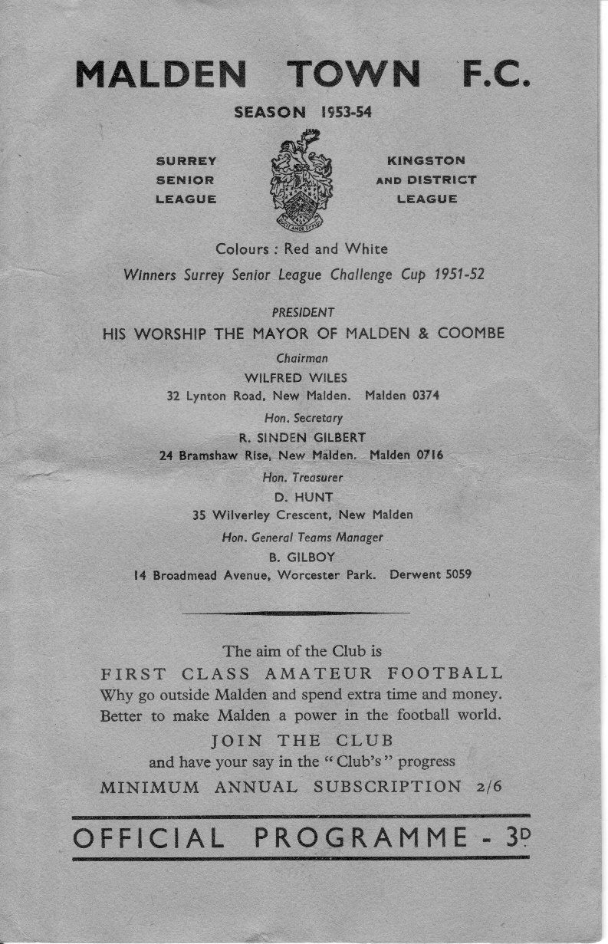
52 years ago today we had a much happier result after a short local trip to Manor Park in New Malden, which was the home of bottom of the Surrey Senior League Malden Town. We had already defeated them 6-1 in an Amateur Cup tie, but we faced them in the Surrey Senior Cup as a result of a shock victory over Sutton United. There was to be no further shock as we won comfortably 3-0 with goals from Bill Wiles (2) and Gordon Hurst and would eventually reach the Final that season. (see programme pictured).

34 years ago today we took on Leytonstone / Ilford in the Quarter – Final of the London Senior Cup. The recently merged club were awesome this season, reaching the First Round of the F.A. Cup just as a starter. They would eventually win the Isthmian League, the League Cup, the Essex Senior Cup and the London Senior Cup under the astute management of a young chap by the name of John Still. I wonder what happened to him!

Anyway, despite their incredible pedigree, we weren’t too bad ourselves, having defeated seven teams from a higher level by that stage of the season and only narrowly losing to Altrincham in the last 32 of the F.A. Trophy seven days previously. We took the Stones all the way to the second half of extra time before three goals for the visitors gave the score line an unfair gloss.

Despite the result it was an incredible time to be an Epsom supporter, but what we didn’t realise then was that dark clouds were gathering and within a fortnight the Pat O’Connell era would be consigned to history after eight and a half years, taking almost all of the squad with him. Players like Peter Gaydon, Ian Finch, Dave Dyer and even Tommy Tuite departed, although he would return just over two years later. Still, every dark cloud has a silver lining and the Adrian Hill era was about to begin!

Surrey Senior Cup
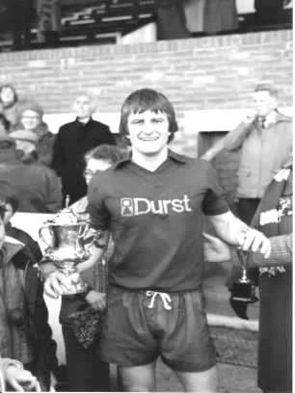
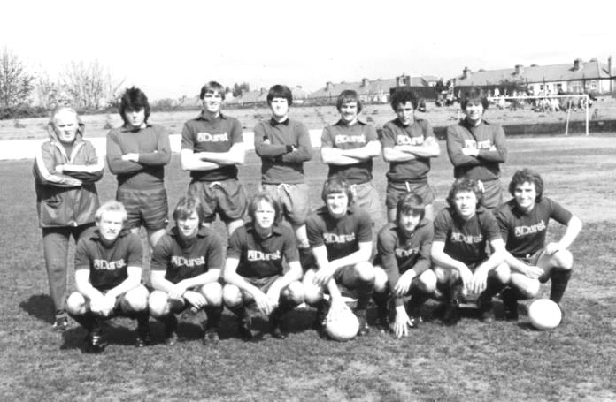
Second Round
Knaphill | 4-3 | Ashford Town (Mx)
Chipstead | 4-1 | Chessington & Hook United
Colliers Wood United | 1-3 | Whyteleafe
Corinthian Casuals | 1-1 - 4-2p | Egham Town
Croydon | 3-3 – 2-3p | Farnham Town
Godalming Town | 1-0 | Guildford City
Horley Town | 2-2 – 3-4p | Badshot Lea
Leatherhead | 3-0 | Carshalton Athletic
Merstham | 3-0 | South Park
Met Police | 3-2 | Dorking Wanderers
Molesey | 2-1 | Raynes Park Vale
Redhill | 0-3 | Tooting & Mitcham United
Sutton United | 3-0 | Walton & Hersham
Walton Casuals | 1-1 – 8-9p | Kingstonian
Westfield | 2-0 | Chertsey Town
Woking | 10-0 | Sutton Common Rovers
Third Round
Godalming Town | 1-2 | Tooting & Mitcham United
Whyteleafe | 6-0 | Farnham Town
Kingstonian | 0-1 | Leatherhead
Played at Leatherhead F.C.
Badshot Lea | 1-5 | Merstham
Westfield | 1-4 | Woking
Played at Woking F.C.
Met Police | 0-1 | Molesey
Knaphill | 3-0 | Chipstead
Corinthian Casuals | 1-3 | Sutton United
Quarter - Finals
Molesey | V | Woking
Knaphill | V | Sutton United
Whyteleafe | V | Tooting & Mitcham United
Leatherhead | V | Merstham

CCL Premier Division Club Directory
A.F.C. HAYES Telephone: 0208-845-0110 - Ground: Farm Park, Kingshill Avenue, Hayes, Middx. UB4 8DD - Colours: Blue and White Stripes/Blue/Blue

ASHFORD TOWN (Mx) Telephone: 01784-245908 - Ground: The Robert Parker Stadium, Short Lane, Stanwell, Middx. TW19 7BH - Colours: Tangerine & White Stripes/Black/Tangerine

BADSHOT LEA Telephone: 01252-320385 - Ground: Ash United FC, Shawfield Stadium, Youngs Drive, Shawfields Road, Ash, Hampshire. GU12 6RE - Colours: Claret/White/Claret

BEDFONT SPORTS Telephone: 0208-831-9067 - Ground: Bedfont Sports Club, Hatton Road, Bedfont, Middx TW14 8JA - Colours: Red & Black Hoops/Black/Red & Black Hoops

CAMBERLEY TOWN Telephone: 01276-65392 - Ground: Krooner Park, Wilton Road, Camberley, Surrey. GU15 2QW - Colours: Red & White Stripes/Blue/Red

CHERTSEY TOWN Telephone: 01932-561774 - Ground: Alwyns Lane, Chertsey, Surrey. KT16 9DW - Colours: Royal Blue & White Stripes/Royal Blue/Royal Blue

CHESSINGTON & HOOK UNITED Telephone: 01372-602263 - Ground: Chalky Lane, Chessington, Surrey. KT9 2NF - Colours: Blue/Blue/Blue

COLLIERS WOOD UNITED Telephone: 0208-942 8062 - Ground: Wibbandune Sports Ground, Robin Hood Way, Wimbledon. SW20 0AA - Colours: Blue & Black Stripes/Black/Black

COVE Telephone: 01252-543615 - Ground: Oak Farm Fields, 7 Squirrel Lane, Cove, Farnborough, Hampshire. GU14 8PB - Colours: Yellow/Black/Yellow

EPSOM & EWELL Telephone: 01737-553250 - Ground: Chipstead FC, High Road, Chipstead, Surrey. CR5 3SF - Colours: Royal Blue & White Hoops/Royal Blue/Royal Blue & White Hoops

FARNHAM TOWN Telephone: 01252-715305 Ground: Memorial Ground, Babbs Mead, West Street, Farnham, Surrey. GU9 7DY Colours: - Claret & Sky Blue /White/ Claret & Sky Blue

GUILDFORD CITY Telephone: 01483-443322 - Ground: The Spectrum, Parkway, Guildford, Surrey. GU1 1UP - Colours: Red & White Stripes/Black/Black

HANWORTH VILLA Telephone: 0208-831-9391 - Ground: Rectory Meadows, Park Road, off Hounslow Road, Hanworth, Middlesex. TW13 6PN - Colours: Red & White Stripes/Black/Black

HARTLEY WINTNEY Telephone: 01252-843586 - Ground: Memorial Playing Fields, Green Lane, Hartley Wintney, Hants RG27 8DL - Colours: Orange & Black/ Orange /Orange

HORLEY TOWN Telephone: 01293-822000 - Ground: The New Defence, Anderson Way, Court Lodge Road, Horley, Surrey. RH6 8SP - Colours: Claret & Sky Blue/Claret/Claret

KNAPHILL Telephone: 01483-475150 - Ground: Brookwood Country Park, Redding Way, Lower Guildford Road, Knaphill, Surrey. GU21 2AY - Colours: Red/Black/Red

SUTTON COMMON ROVERS Telephone: 01932-866386 - Ground: Sutton United FC, Gander Green Lane, Sutton, Surrey SM1 2EY - Colours: Yellow/Black/Black

RAYNES PARK VALE Telephone: 020-8540-8843 - Ground: Prince Georges Playing Field, Grand Drive, Raynes Park, London. SW20 9NB - Colours: Blue/Blue/Red

REDHILL Telephone: 01737-762129 - Ground: Kiln Brow, Three Arch Road, Redhill, Surrey RH1 5AG - Colours: Red and White Stripes/Black/Red

SPELTHORNE SPORTS Telephone: 01932-961055 - Ground: Spelthorne Sports Club, 296 Staines Road, Ashford Common, Ashford, Middx. TW15 1RY - Colours: Light & Dark Blue/Dark Blue/Light Blue

WESTFIELD Telephone: 01483-771106 - Ground: Woking Park, Kingfield Road, Woking, Surrey. GU22 9BA - Colours: Yellow/Black/Black

WINDSOR Telephone: 01753-860656 - Ground: Stag Meadow, St Leonards Road, Windsor, Berks SL4 3DR - Colours: Red/Red/Red

Centre page for results

Centre page for results

From behind the goal
Epsom & Ewell 3-0 Redhill
Combined Counties League – Premier Division – Tuesday 2nd February 2016

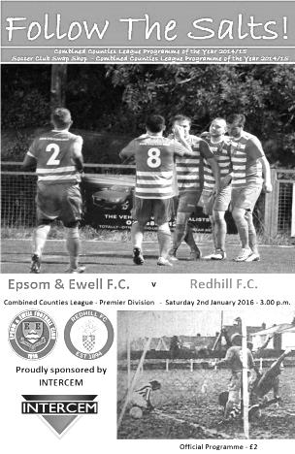
Flying start leads to a comfortable evening

The Salts and the Lobsters have met on many occasions historically. Many of those matches were watched by thousands and it has to be said that our opponents held the balance of power over the series. However, that pattern is changing and our 3-0 win last night represented our fifth straight win over them, dating back to 1976, all of which were achieved without conceding a single goal. It was just a pity that only 47 people were there to see it.

The starting eleven contained Matt Tanton who had completed his suspension, while Alex McKay continued to show his versatility by moving up from full back into midfield in place of the injured Carl Downs. Further forward Tom Neale and Matt Ferdinando were recalled to the starting line up ahead of Reisse Griffin and Rob Hendry who would both join the action later.

Redhill's previous two visits in 2001 and 2009 were for Surrey Senior Cup ties and this League game finished with an identical scoreline to those previous matches. To be honest though, I'm not sure that Redhill deserved such a heavy defeat as the Salts produced a performance that was inconsistent and patchy. There were some superb passages of play, but there were also large segments of the game where it was very scrappy and ultimately the three goal difference came down to the fact that we had better finishers in our team than they did.

And when you are talking about finishers, there are few better than Kyle Hough who required just one minute and fifty-five seconds to open his account last night. Ferdinando, making his fiftieth appearance in this match had already dragged a shot across goal from a good position in the opening twenty seconds, but his free kick from out on the touchline was flicked on by a defender, but only as far as Craig Hastings who headed the ball back across goal where Hough had time to turn, collect the ball and fire home from close range. Hastings appeared to be standing in an offside position so credit goes to the officials who spotted that it was a defender who had made the initial contact.

The visitors were completely at sea for the first ten minutes and Neale headed in Hough's cross but was ruled offside after just 5 minutes. Rhys North was next to try his luck with a powerful effort from nearly 35 yards out but it was just wide of Oliver Moore's left hand post. A few minutes later the visitors had a long range effort that forced Michael Eacott into a low save. I made a note of this as it looked like it would be a long night for the visitors and that they may not have too many opportunities, but within six minutes they had carved out another two chances; one which was well blocked by our defenders and another that was deflected for a corner. They were getting closer.

It was therefore a relief when we extended our lead in the 29th minute. The ball was

smashed into the net by Tom Neale who gave Moore no chance whatsoever from 12 yards, but the goal itself was created by Matt Farrell. Our apparently tireless Captain won the ball in the air; then reached the loose ball first, pushed on and sent the ball on a plate for Neale. A superb goal with two great individual contributions.

The visitors put a couple of dangerous balls into our box but they were either gathered easily by Eacott or fizzed across our six yard area harmlessly and the half finished with the first booking of the night when Qudos Bolagi collided with Ferdinando. Five minutes after the restart Ferdy had his revenge, collecting a half clearance and running back in at pace on one of his mazy runs before casually flicking the ball into the far corner from 12 yards with the outside of his right foot to add to his already impressive highlight reel of quality goals.

Other chances came and went. Ferdinando sent a header wide after leaping like a salmon to reach a good left wing cross at the far post and then Hough broke through on goal but from an angle his shot beat the keeper but missed the near post by about 2 inches, nestling into the side netting instead but with Ferdinando waiting in the box for a tap in.

After 66 minutes the game took an unfortunate turn when McKay received a red card for denying a goal scoring opportunity. He missed his clearance and in the process then took the Redhill player down with him. No thought was given as to whether McKay had been nudged in the first place, leading to the original miskick, but once the foul was given, I think everyone knew what was coming. My only issue with this was that I thought this rule was brought in to cater for the "professional foul" where someone deliberately stops someone in a good position. Clearly this was an accidental collision, and arguably it was a foul the other way in the first instance but yet again we lose another player before the final whistle and our third this season under this particular rule. It was ironic in that he had only dropped into defence three minutes earlier when Dan Dean had been given a rest by the Management. What was admittedly quite funny after the incident was that our man, who is also a qualified referee, then took his place in the dug out for five minutes before being reminded by the referee that he had to leave the field of play entirely!

The visitors sent the subsequent free kick over the bar but despite their one man advantage the pattern of play didn't change that much and Neale was unfortunate when being unable to direct North's superb cross on target while Hastings was really unlucky to see his header from a corner disallowed for what looked like a push from one of our other players, judging from where the referee was pointing when he gave the free kick against us.

That corner by the way, was taken by the returning Sam Robinson who has rejoined from Molesey and came on for the last half an hour. With other new players also signing last night, Glyn is well aware that we need some new faces to see us through two games a week from now until the middle of March. He also remarked that it will help improve competition for places and it has to be said there were times in this match when we weren't quite on the ball. Having said that, we still took the three points and remain third. Many clubs would be envious of that, including Redhill, who look increasingly certain to finish in the bottom three at this stage. I hope we will see them again next season, but that decision may be taken out of their hands, despite their spirited performance at High Road.

Team: Michael Eacott, Rhys North, Matt Tanton, Dan Dean, Craig Hastings, Alex McKay, Savvas 'Agi' Panayiotou , Matt Farrell (c), Kyle Hough, Tom Neale, Matt Ferdinando

Subs: Sam Robinson for Dean (63), Rob Hendry for Hough (80), Reisse Griffin for North (85)

From behind the goal
Camberley Town 1-1 Epsom & Ewell
Combined Counties League – Premier Division – Tuesday 9th February 2016

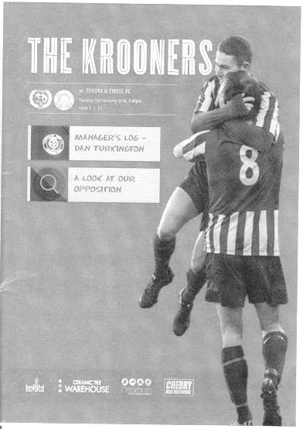
Combative, stop - start encounter at Krooner Park finishes with honours even

We have now visited all four of the other teams that have been around us at the top of the table and remain unbeaten after this 1-1 draw at Camberley Town. However, Glyn and his team will be disappointed that we did not come away from Krooner Park with all three points after chances to win the match went begging.

We made a few changes to our line-up, following the home win over Redhill. New signing Bentley Graham came straight into the middle of the park to provide Matt Farrell with help, while Savvas 'Agi' Panayiotou was on the bench. Additionally, Rob Hendry returned to the starting eleven in place of Kyle Hough who had been struggling ever since he injured his knee at Ashford in October and wasn't able to play. We made one other notable change in terms of positions as Alex McKay moved over to left back and Matt Tanton was pushed further forward.

These days a trip to Krooner Park is a daunting fixture on the calendar. They are in excellent form right now and of course visit Hereford in the Quarter - Final of the F.A. Vase in eleven days, which led to this match being brought forward from that date. However, our players were clearly up for the challenge and although Michael Eacott had to make a good block with his feet after a couple of minutes, the opening exchanges were even. In fact we probably should have taken the lead in the ninth minute when Tom Neale got through and reached the ball ahead of the keeper Craig Bradshaw but in lifting his shot over the keeper it just cleared the bar too.

The game started to be broken up by a number of fouls. I'm not entirely sure how old the referee was, but he looked very young and maybe because of this he struggled to exert any control over the players last night, even after losing his patience and booking a number of them throughout the game. The first case in point occurred in the opening twenty minutes when we broke out of defence and Tanton knocked the ball past their Captain Dale Webb who stepped across and body checked him to the ground. He knew exactly what he was doing and when no card was produced, the message it sent out was that this sort of thing would happen all night and it frequently did. It set the tone for the evening.

Eacott made a good low save at the far post on 23 minutes before another foul on Tanton finally resulted in the first booking of the night, although Matt Ferdinando wasted the free kick. Things were looking quite comfortable at this stage so it was particularly frustrating to concede a penalty moments later as McKay appeared to lose the flight of a high ball and collided with their striker Perry Coles, with both players ending in a heap. Carl Garstang then scored from the spot to give the home side the lead after 30 minutes.

Within six minutes we were level with a spot kick of our own after Tom Neale turned Webb on the edge of the area and ran at goal before being brought down by him, earning a booking. It looked close to the line of the penalty area from where I was, but the referee was certain the foul had

occurred inside the box and having now seen the match video of the incident, it's clear it was the correct decision. The only thing we were wondering about behind the goal was who would take the kick with no Hough on the field, but up stepped Rob Hendry and he finished confidently to bring us back on terms.

The half concluded with no further real incident with exception of a booking for Farrell, but within four minutes of the second half we had one as Ferdinando was taken out very late after delivering a dangerous right wing cross. Fortunately he was able to continue after treatment, which was more than could be said for Garstang who had to witness a yellow card being shown at him as he was taken off.

Rob Lazarczuk was next in the book for the home side, this time for having a bit of a moan but they had an opportunity to retake the lead after a good right wing run and cross but the shot was wide from a good position. Little did the home side realise it would be their last real chance in the match which was beginning to deteriorate rapidly as an advert for football. Further fouls by the home side broke up the play constantly and in the 70th minute we really should have taken the lead when Neale faced another one on one with Bradshaw, but looked uncertain and tried to dink the ball past him, but his effort carried no power and their number one was able to claw it away.

Hendry was next to have a try from a wide angle and his shot swerved late, meaning that Bradshaw could only parry the ball before a defender cleared for a corner and although that came to nothing Neale found himself with another great opportunity and this time did chip the out coming keeper but his attempt was about a foot wide and ended up in the side netting.

In the 89th minute a terrible backpass from the home side put Neale in a race with Bradshaw to a ball out near the touchline which Neale won, but he hesitated in deciding whether to cut in and shoot or to cross early and the defenders were back to clear the danger when the ball came in.

Unfortunately the game boiled over still further in injury time when James Hubbard went in late on Eacott, leading to a scuffle and requiring his replacement by Adrian Jones. Hubbard only received a yellow card, although Lazarczuk, despite already having a yellow card, then decided to get involved, leading to a second yellow for him, and although we knew behind the goal, it required the Assistant to remind the referee that two yellows equalled a red and finally their striker was dispatched to avoid a "Graham Poll" situation! Following that, new boy Elliott Thompson, who had only been on the field for ten minutes in place of Farrell picked up a yellow card too and after six minutes of extra time the game finally concluded.

Some would have called this game combative. Their Manager Dan Turkington, in a very honest and forthright interview after the game called it "sterile", while Glyn Mandeville called it "a battle". In truth I felt we stood up to some very physical tactics quite well and although it wasn't a pretty game to watch by any means, it certainly had its exciting moments and although Neale will be thinking that he should have taken a couple of his chances last night, he should remember that he did extremely well to make as many chances as he did, in addition to winning the penalty. He was a handful for the league's best defence throughout this game and will improve still further with experience.

As for where we can finish this season, Hartley won again and it looks a tough ask if we are to catch them, but we know we are in a battle with some exceptional teams this season, yet none of them have managed to beat us on their own ground. Well played lads!

Team: Michael Eacott, Rhys North, Alex McKay, Dan Dean, Craig Hastings,
Bentley Graham, Matt Tanton, Matt Farrell (c), Rob Hendry,
Tom Neale, Matt Ferdinando

Subs: Elliott Thompson for Farrell (84), Adrian Jones for Eacott (95)

Every Opponent A-Z
Over the years we have played many, many different opponents. Exactly how many is a difficult question, as it all depends on your definition. Are Camberley & Yorktown different to Camberley Town, or are Epsom Town different to Epsom F.C. or Epsom & Ewell F.C.?

In my analysis I have classed them as the same team, and will work through them all from A to Z. Some we have played many times, whilst others we have met just once or twice. Enjoy!

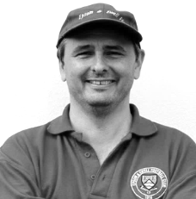
Royal Naval Depot (Chatham): Played 13 - W11 D0 L2 - F48 A18 - PPG - 2.54 - Fantastic

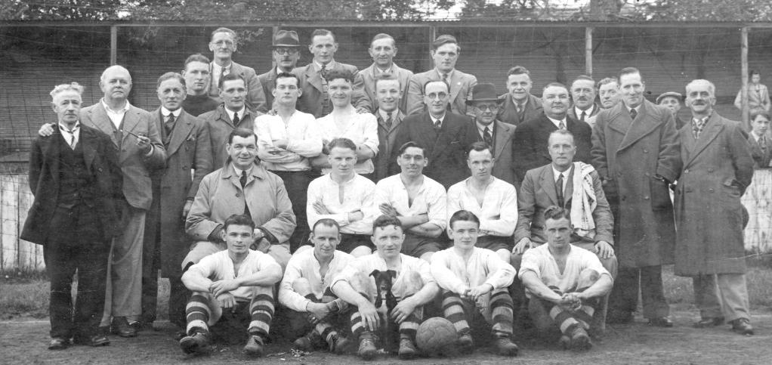
Of all the clubs we have played more than a handful of times I know least about the Royal Naval Depot club from Chatham. What I do know is that they originally had links to the Royal Engineers who appeared in three of the first four F.A. Cup Finals, being runners up to the Wanderers in 1872 in the first final and then winning the competition itself in 1875 against Old Etonians after a replay.

So clearly Chatham had a very strong heritage and the team were good enough to play in the London League Premier Division from the 1936/37 season, without any requirement to work their way through the lower divisions. However, once there, and despite the inclusion of former professional Bernard Radford, they found the challenge too much, with a high water mark of ninth over the six seasons that they met us.

Our first meeting came on Saturday 20th February 1937 at West Street where we won 5-2 with five different players getting on the score sheet and results continued in that vein with the return in April at Chatham finishing 4-1 in our favour. In 1937/38 we raced to a 6-0 half time lead, eventually winning 10-1 at West Street before edging the away game by three goals to two in the January of 1938.

Two further wins followed in the final pre-war season; 4-1 away and 4-0 at home on the final day of that season and the picture below taken that day was therefore our final one before the War.
Epsom FC: Fourth from the left in the main standing row was keeper David Wesley.
The other players were: Back Row: unknown, Bryn Evans
Middle Row: Charles Pettett (Chairman), unknown, Tommy Rochester, A.F.Curtis, Sid Bristow (Trainer)
Front Row: George Baker, Jimmy Jones, Bobby Gill, Geoff Collins, Billy Heal.
The unknown players are: W.H.Calvert and J.H.Stubbs
Of the non-players in the main standing row, we have Harry Cottee (groundsman), Fred Talbot-Butler
(former v-c), David W.G .Jones (Press Sec) and fifth in line is Dick Wilson, a regular player

We rejoined the London League in 1945/46 but the Depot waited until the following season and despite being a very average team ourselves at that point, we resumed normal service defeating them 4-0 on 7th December 1946, although they had their revenge in the final match of the season by five clear goals. We had a full side out so had no excuse. It’s possible that they were able to call on stronger players that day as the match was played on 31st May 1947 following a devastating winter, the like of which has only been seen once since, in 1962/63. This unsurprisingly remains the latest date we have ever played on in a season!

After playing them last that year, we faced them at home in the opening day of the next season in the London League Cup, where despite leading at the half, we lost 3-2. It is bizarre that in 13 matches they only beat us twice, yet they were consecutive matches! (see programme left)
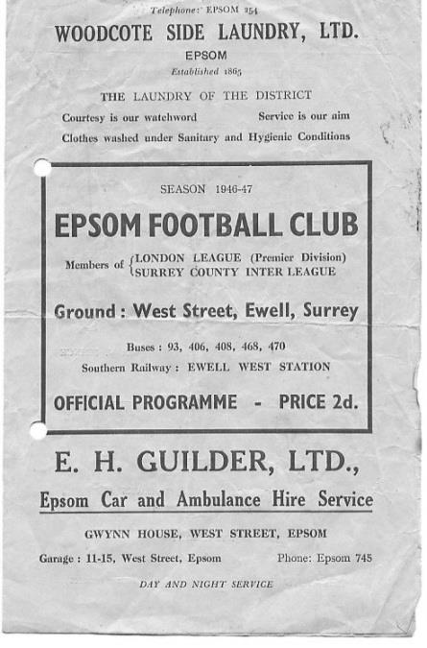
Our two league meetings of 1947/48 were both held in 1948 and a Bill Cutter hat trick secured a 3-0 win over there while two goals from Ken Minter and another from Les Gilbert gave us a 3-1 win at West Street.

Our final two matches took place two weeks apart, in March 1949 with our boys winning 2-1 in Chatham before signing off with a 4-1 win at West Street. By then we probably knew that this was likely to be our last meeting as we had already applied for the Corinthian League and that was how it turned out.

It is not clear how long they remained in the London League but I have traced that they were in the Kent Amateur League (not to be confused with the Kent League) for two seasons from 1954 to 56 but have found nothing else from that point. I still do not even know exactly where in Chatham they played, so if anyone knows, please tell me!

Royal Marines: Played 1 - W1 D0 L0 - F3 A2 - PPG - 3.00 - Perfect

This was another of these post war friendly challenge matches at West Street and we hosted them on Saturday 9th February 1946, winning 3-2 although this probably wouldn’t have been the case had they not allowed us the luxury of a half time substitute, due to injury, as Sargeant D.F. Bayly, as he was still known, came on for the second half.

Royal Ordnance Factories: Played 1 - W1 D0 L0 - F6 A2 - PPG - 3.00 - Perfect

We hosted the Royal Ordnance Factories, a Woolwich based organisation in an Amateur Cup tie on Saturday 29th September 1962. They had been drawn at home but waived their right to ground choice so that a gate could be taken. Not that it was much of a gate as we were quite a poor team back then, despite the Management of former player Fred Chitty, who had success in his first spell in charge a few years previously.

We still had far too much for them and won easily 6-2 with a hat trick for Derek Prowse before Leatherhead knocked us out in the next round.

Player Sponsorship
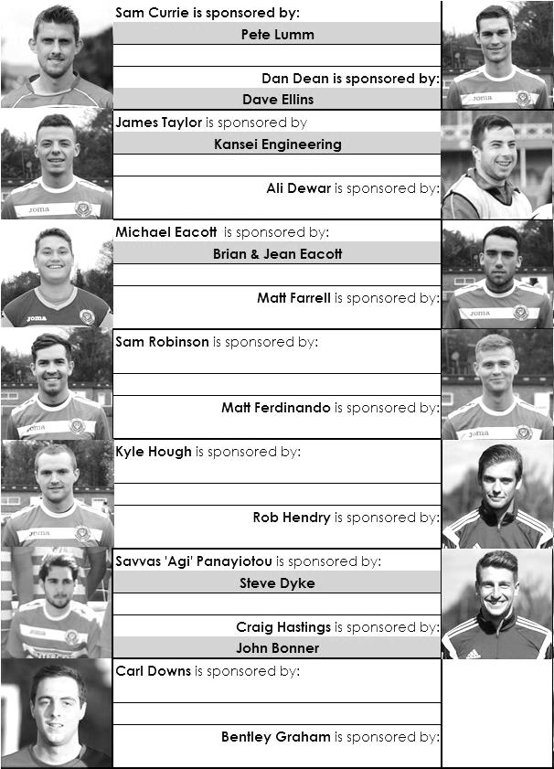

Here is the current list for the 2015/16 season showing all of our players and Management that are currently available for sponsorship this season.

Sponsorship costs just £40 and it is easy to do. Just select a player who has not been previously sponsored and let a Committee Member know that you would like to sponsor them. Beware though. Until we have received the money it is possible for someone to jump in front of you, so don’t delay, sponsor today!

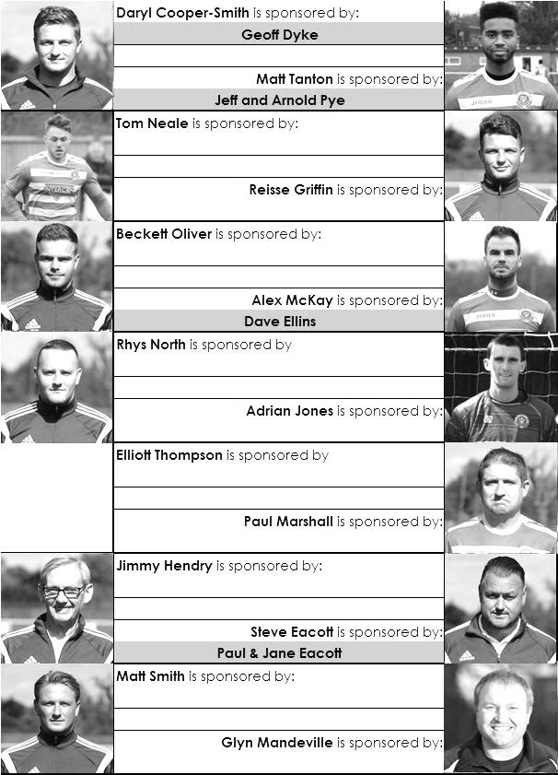

F.A. Vase – Latest Positions
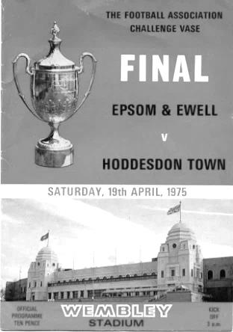
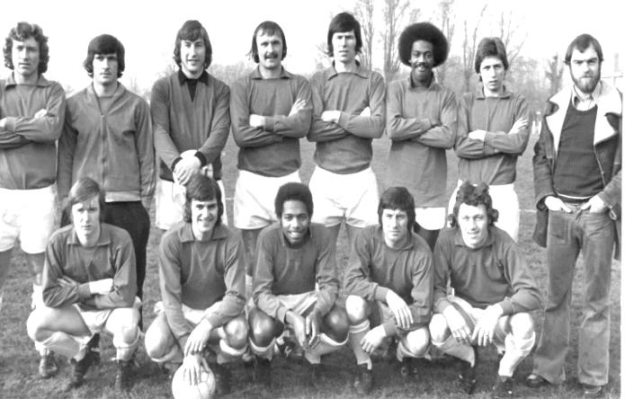

Fifth Round - (league positions correct after 6th February)
Ipswich Wanderers | 1-1+r13/2 | Bowers & Pitsea
Eastern Counties – 15th |  | Essex Senior – 5th
Sunderland RCA | 2-3 | Bristol Manor Farm
Northern – 10th |  | Western League – 2nd
Camberley Town | 5-0 | Newton Aycliffe
Combined Counties – 3rd |  | Northern – 8th
Berkhamsted | 1-2 | Morpeth Town
South Midlands – 6th |  | Northern – 3rd
Cleethorpes Town | 1-2 | Kidlington
Northern Counties East – 5th |  | Hellenic – 4th
Nuneaton Griff | 0-3 | Salisbury
STEP 6 - Midland Division 1 – 5th |  | Wessex – 1st
Ashford United | 1-1+r 3-2 | Dunston UTS
Southern Counties East – 3rd |  | Northern – 5th
Hartley Wintney | 1-4 | Hereford
Combined Counties – 2nd |  | Midland – 1st
Quarter – Final – 20th February
Hereford | V | Camberley Town
Salisbury | V | Ashford United
Morpeth Town | V | Bristol Manor Farm
Ipswich W / Bowers & P | V | Kidlington

Congratulations Matt!
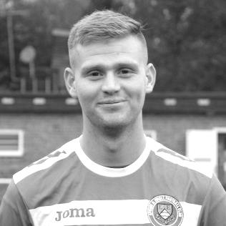
Our latest congratulations go to Matt Ferdinando, who celebrated his 50th appearance against Redhill with another superb goal; his twelfth in total.

Not only is he scoring at the rate of one in every four matches, but most of them are spectacular too, from his opportunist 45 yard strike at Hartley Wintney to his brilliant flying overhead kick at home to Farnham.

Matt was one of the first players to join the club following the confirmation of Glyn as Manager and it didn’t take long before he was making headlines by winning two penalties at Badshot Lea after producing two great runs that confused the defenders on each occasion. Only three days later he was knocking in a beauty from distance at home to Spelthorne, following this with a late winner in the same match when he cleverly blocked a defenders clearance into the net. Equally happy on the wing or in the centre of the park, I think he will improve still further and look forward to seeing that happen.

Matt becomes the 260th player to reach this mark, and although I have said before that this sounds like a lot of people, we have been going for over 90 years as a Senior club, so there were always going to be a few! It doesn’t make it any less of an achievement! Here’s to many more goals and appearances.

Player Profile – Number 12 – Michael Eacott
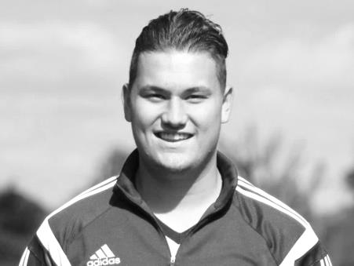
Our latest player profile is from the big man between the posts, Michael Eacott.

Age: 20

Position: Goal keeper

Club supported: Chelsea

Favourite Food: Chicken

Favourite Film: Goal 1 / Jimmy Grimble

Messi or Ronaldo: Ronaldo

Favourite Drink: Strawberry & Lime Rekorderlig

Favourite Ground played at: Griffin Park, Brentford FC

Best Moment for Epsom & Ewell: My first clean sheet for the club. 3-0 at Spelthorne Sports – 27th September 2014

Describe the Gaffa in three words: Funny – Ginger – Banter

Previous Clubs: Chipstead, Erith Town, Colliers Wood, Brentford (academy)

Michael’s Playing Stats: First Team Debut : 02/08/2014

Appearances: 70 - Sub: 0 - Total: 70 - Goals: 0

Club Fund Raising Evening – 23rd January
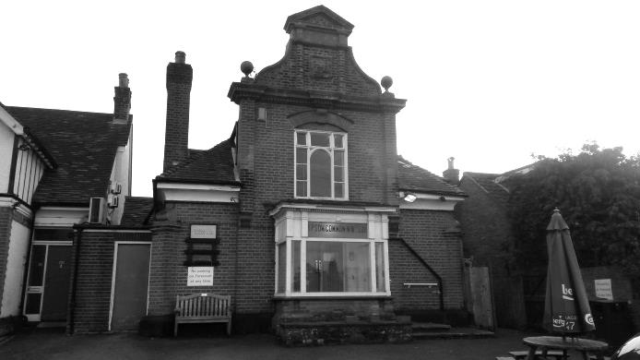
On Saturday, 23rd January we held our first fundraising event of the season at the Epsom Common Working Mens Club (pictured right).
It was a quiz with a twist; a categories evening, run by former local footballer Martin Firmo. The idea behind it would be that he would choose a category and you would have to come up with an answer in that category, but not the one he had chosen or you would pay a fine!

Seven teams entered the event as over thirty people were present, although bizarrely one group left early; maybe unaware of the concept which was that it was not a serious quiz, just an opportunity to have a bit of fun!

Anyway, they weren’t missed and we moved on, covering various categories as diverse as places where you might find a flag or a ladder, over to famous sisters and even different chat up lines! Additionally, there were rounds where you had to mimic a sport and another where you had to stand up and sing a Beatles song. Unfortunately, (or maybe fortunately) my picture of one of the groups singing Yellow Submarine as if it were being presented at a funeral does not come with accompanying sound, although the team thoroughly deserve to be named and shamed here, don’t they Mr Chairman!
The Yellow Submariners: from left -
Barry Channell, Paul Marshall (obscured), John Bonner, Pete Lumm, Pete Beddoe

The answers came thick and fast, mostly thick, although Treasurer Steve Dyke was getting plenty of exercise after volunteering to be the runner between teams who would relay the answers back to Quizmaster Martin. After an hour and a half of intense competition, accompanied by some substantial banter, we got down to the final two teams and the final, all important question: Name a sport with a ball in it!
The answers flew back and forth at pace like a tennis match as each team tried to think of more obscure sports, while at the same time both avoiding football which they probably thought would be the rogue answer. After about ten answers each, from Aussie Rules Football to Polo and beyond, Alex McKay let Rhys North have his idea, Lacrosse! (see picture)

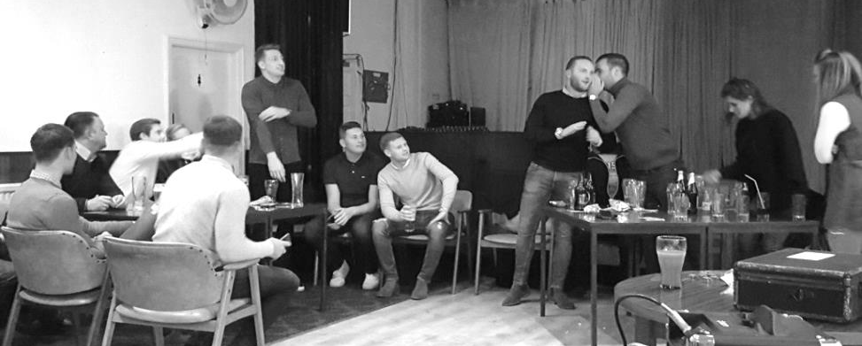
Surely this was another superb suggestion, but no! It was the rogue answer and we had our winners.

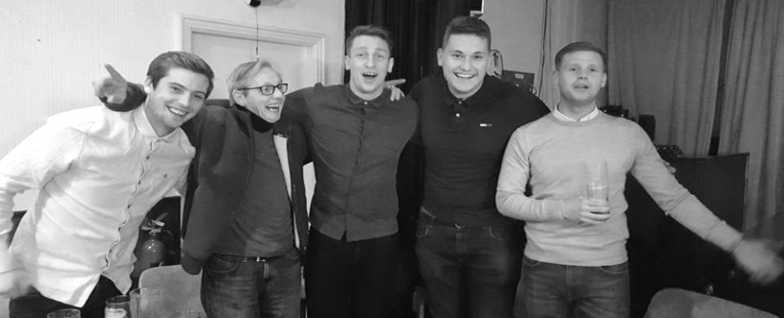
Additionally there should have been a special award for the evening to Rob Hendry from the winning team for his stunning rendition of the Beatles classic Love Me Do! Not sure what the award should have been though!

Our club raised just over £300 on the night and are extremely grateful to all who turned up and really put the effort in. Except Rob in the singing round, obviously!
Our winners:
Rob Hendry, Jimmy Hendry, Craig Hastings, Michael Eacott, Matt Ferdinando

Match and Ball Sponsorships – 2015/16
Opponent | Date | Match Sponsor | Match Ball Sponsor
Hoddesdon Town | 18/07/15 | Geoff Dyke
Windsor | 08/08/15 | Club President - Stella Lamont
Erith & Belvedere (FAC) | 16/08/15 | Committee Member - Mike Lovett
Raynes Park Vale | 31/08/15 | EEFC Management Committee
Colliers Wood United | 08/09/15 | Bookham Building Shop – www.buildingshop.co.uk
AFC Hayes | 19/09/15 | John Bonner
Farnham Town | 26/09/15 | Ezara and Inaya Beddoe – our youngest supporters!
Chertsey Town | 17/10/15 | Club Media Officer – Richard Lambert
Dorking Wanderers (SSC) | 20/10/15 | Tony Ferdinando
Chessington & Hook United | 07/11/15 | Paul Merritt
Hanworth Villa | 21/11/15 | Maggie Beddoe
Guildford City | 05/12/15 | Pete Lumm
Sutton Common Rovers | 19/12/15 | Marvin Hough
Ashford Town (Mx) (LC) | 12/01/16 | Pete Beddoe & Steve Dyke
Redhill | 02/02/16 | David Lawton
Bedfont Sports | 13/02/16 | Bookham Building Shop – www.buildingshop.co.uk
Hartley Wintney | 23/02/16
Horley Town | 27/02/16
Spelthorne Sports | 01/03/16 | In memory of Chris Henry
Knaphill | 12/03/16
Cove | 15/03/16
Westfield | 26/03/16 | Nathan Lambert
Badshot Lea | 09/04/16
Camberley Town | 16/04/16
Ashford Town (Mx) | 30/04/16 | Club President - Stella Lamont
Ashford Town (Mx) | 30/04/16 | Brian Eacott | Steve Dyke
For League, League Cup and Surrey Senior Cup Matches:
Match sponsorship - £40.00 Match ball sponsorship - £25.00. Combined £55.00.
For F.A. Cup and F.A. Vase matches:
Match sponsorship - £50.00 Match ball sponsorship - £30.00. Combined £65.00.

Sponsorship includes: ( x2 for match, x3 for match and ball )

Admission, programmes, hospitality, advertising and mascot for the day (if required ).
If you are interested, just speak to a Committee Member, or drop me an email at: richard.c.lambert@gmail.com

We also thank our Kit Sponsors INTERCEM

Salts Super Six Predictor
The Salts Super Six Predictor Competition is live again and the tickets are on sale at the ground. We have five from the Premier League and one from the Championship today.

The competition is easy to play! To win, you simply need to predict the results of the six matches correctly from the three options, fill in the form and make sure it is back with our sellers before the deadline on the ticket.

If you are a club regular, you just need to place your name on the sheet, although if you aren’t, then we’ll need a contact number from you too. We will announce any winners on the website within three working days, so don’t worry we won’t miss you!

The jackpot is now at £189 and who knows how high it could go this time!

Please note that if there is more than one winner, the prize pot would be shared between the winners. All you need to do now is have a go, as many times as you like!

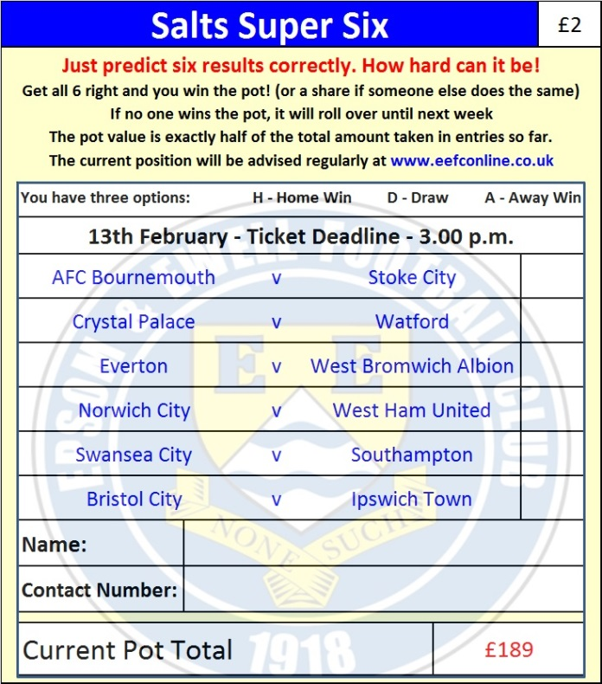

Good luck!

Combined Counties League – Premier Division
Saturday, 13th February 2016 - Kick-off 3.00 p.m.
Epsom and Ewell  (Royal Blue & White hoops) | V |  | Bedfont Sports  (Red and Black)
Squad | NUMBERS |  | Squad
Michael Eacott |  |  | Josh Richardson
Sam Currie |  |  | Tim Pitt
Alex McKay |  |  | Julius Mngadi
Craig Hastings |  |  | Ciaron Brown
Dan Dean |  |  | Billy Jefferys
Carl Downs |  |  | Robbie Sitch
Reisse Griffin |  |  | Paul Johnson
© Matt Farrell |  |  | Adam Roberts
Rob Hendry |  |  | Kyle Giscombe
Tom Neale |  |  | Matt Baxter
Matt Ferdinando |  |  | Jamie Read
James Taylor |  |  | Danny Byron
Beckett Oliver |  |  | Alfie Lazar-Woodward
Kyle Hough |  |  | Dan Taylor
Matt Tanton |  |  | Myles Henry
Savvas ‘Agi’ Panayiotou |  |  | Jack Hurst
Adrian Jones
Rhys North
Alex McGregor
Matt Smith
Jamie Hatfield
Glyn Mandeville | MANAGER |  | Paul Johnson
Matt Smith | ASSISTANT |  | Gary Ross
Steve Eacott / Alex McKay / Jimmy Hendry | COACHES / PHYSIO |  | Jimmy Hibburt
REFEREE: E.Walker (London SW19)
ASSISTANTS: K.Parker (Roehampton), I.Hempel (Chessington)
Today’s Match and Match Ball are sponsored by:
Bookham Building Shop – www.buildingshop.co.uk

OUR NEXT VISITORS TO HIGH ROAD ARE:
Hartley Wintney

Tuesday 23rd February 2016 - Kick-off 7.45 p.m.
Combined Counties League – Premier Division

